National School Backpack Awareness Day is (DAY/DATE)
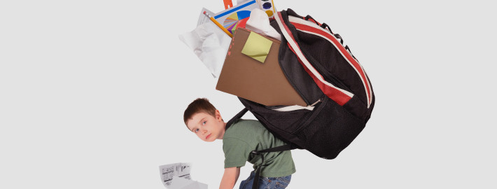
Is YOUR student’s pack too heavy?
Find out on (DAY/DATE) between (TIME OF EVENT) in front of (YOUR SCHOOL).
Get it weighed. Get educated. Lighten your load.

Join us: (LINK TO SIGN UP GENIUS FOR EVENT)
Questions: (CONTACT EMAIL)

